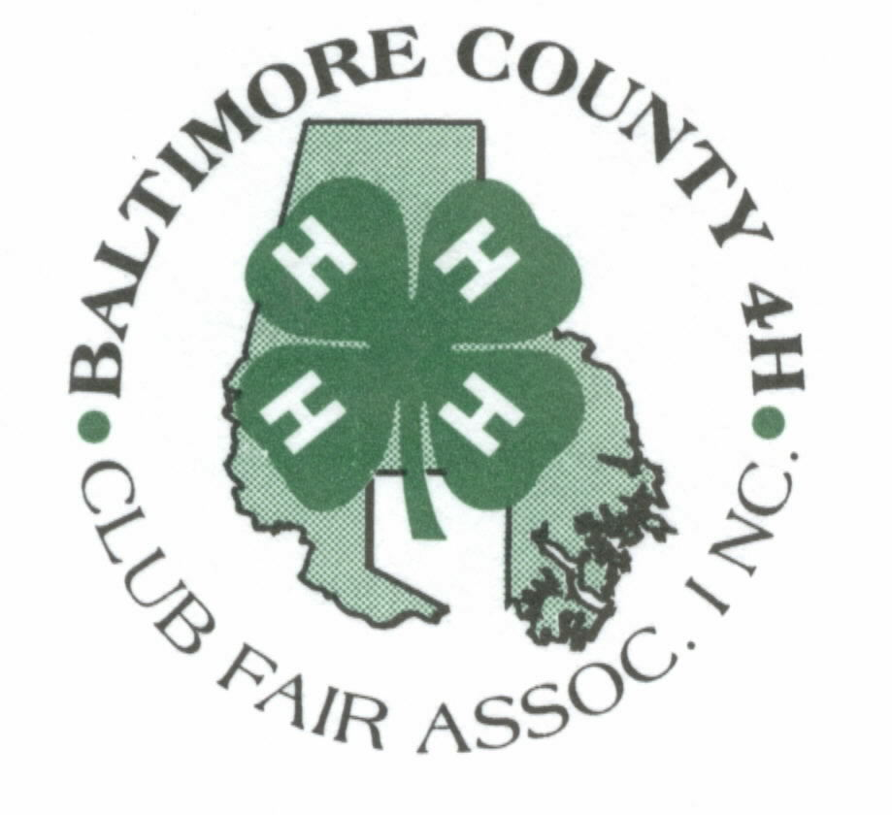
Registration Number ________
Complete Form on-line
Save completed document to your PC
E:mail to Donna dgill2@verizon.net

2019 Baltimore County 4-H Fair
OVERNIGHT CAMPER REGISTRATION

LIST THE NAMES OF ALL PERSONS STAYING IN THIS CAMPER
DURING THE WEEK OF JULY 10 – 14, 2019
- Members must have completed the Health Form and Behavioral Expectations Agreement through the MD 4-H online enrollment system. You must abide by the requirements of your Behavioral Expectations agreement. The Youth Release Form must be mailed to Valerie Harlan by June 1st.

- All UME Volunteers and Parents staying overnight must mail to Valerie Harlon by June 1st, a completed Health Form and Adult Release Form. (Note: If UME Volunteer completed the Health Form through the 4-H online enrollment system, do not mail the form.)

UME Volunteer | 4-Her | Age | Name | Cell Phone # | Hlth Form | Nights of Stay

Camper Manufacturer : ___________________________
Length of Camper : ____________________

Home Address: _________________________________
_________________________________
_________________________________

Home Phone # ____________________________

Emergency Contact: ______________________________ Relationship: _______________________
Phone number: __________________________________

RETURN THIS FORM TO DONNA GILL BY JULY 1st.

